|  |  |
| --- | --- |
| **Project Case – External Document** |  |
| COMP6115  Object Oriented Analysis & Design |
| Even Semester Year 2020/2021 |

* Project Title

Coffee Vibes

* Introduction

Coffee Vibes is one of the cafes located around Bina Nusantara University. To develop this cafe business, a system was created to manage the business activities of the Coffee Vibes cafe.

In this project, we will develop an application to solve the above problem which is made using Java with MVC architecture (Model, View and Controller) and MySQL as database.

This application can be accessed by employees of the Coffee Vibes cafe (Barista, product admin, manager and human resource department). We designed the program by considering several aspects of the needs and business flow provided by the cafe owner.

In the application that we will make later there will be several menus. Here we attach a menu list on the Coffee Vibes application:

* Login menu.
* Barista Menu Consists of a “List Product” menu and a “Cart” menu.
* Product Admin menu.
* Menu Manager Consists of the “Transaction Header” menu, “Transaction Details” menu and “Employee” menu (To firing employee).
* Human Resource Department Menu Consists of the “Coffee Vibes Employees” menu.
* Report / Documentation

1. **Menu Log in**

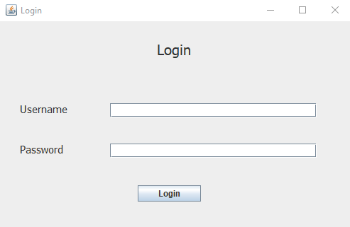

When opening the application, the user (Employee) will see a display like the image above. In this menu, the user must enter the username and password of each role and press the login button.

Note:

* To find out the usernames and passwords of employees, please access the “coffevibes” database.

1. **Menu Barista**

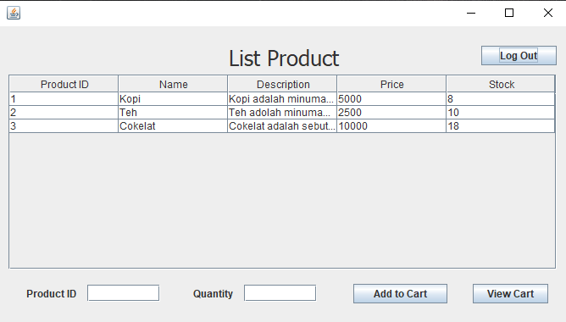

If the user (Employee) is logged in as "**Barista**", the user will be taken to the barista's main menu, "**List Products**". In this menu, the user will see a table containing a list of products sold at the Coffee Vibes cafe.

In addition, if there is a customer who wants to order a product, the barista can enter the productID and quantity of the product that the customer wants, then press the "Add to Cart" button.

To see a list of products that have been selected by a customer, the user can press the "View Cart" button.

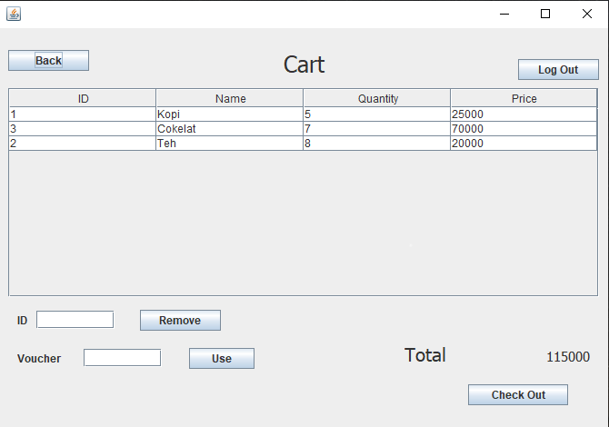

After the user presses the "View Cart" button, a display like the image above will appear. The display is the "**Cart**" menu. In this menu, a table will be displayed containing a list of products that have been selected by the customer.

In addition, in this menu, if the customer wants to cancel the order, the user can enter the productID and press the "Remove" button. Customers can also use a voucher to get a price reduction (Discount), where the user will enter the voucherID into the system.

After the user and customer reach an agreement. The user can press the "Check Out" button to see the total price of the products that have been selected by the user.

In this menu, there is a “Back” button to return to the “**List Product**” menu, and on both pages there is a “Log out” button to exit the menu and return to the “**Log in**” menu.

1. **Menu Product Admin**

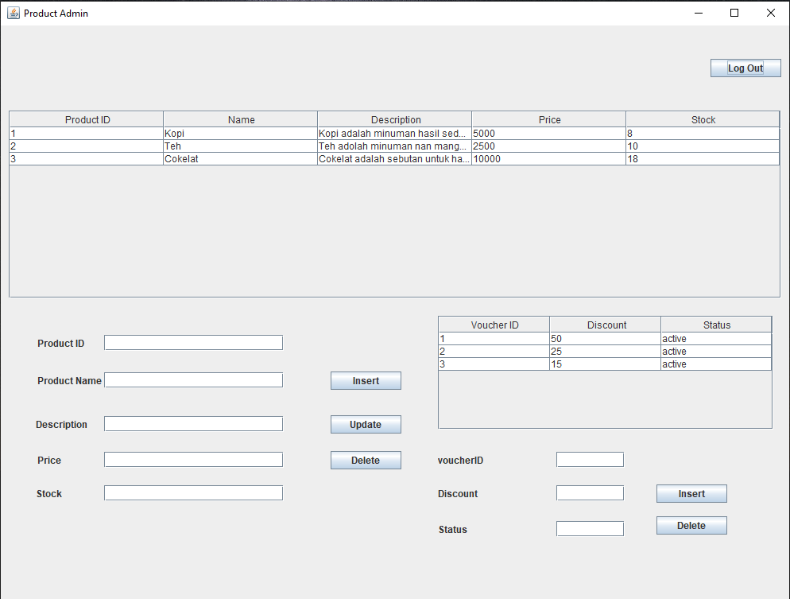

If the user (Employee) logs in as "**Product Admin**", the user will be taken to the main product admin menu which will display a table list of products sold at Coffee Vibes cafe and a table list of vouchers that can be used by customers.

In addition, in this menu, users can also insert, update and delete products. Where when inserting and updating, the user only needs to enter the product name, description, price and stock data. When the user wants to delete data, the user only needs to enter the productID data.

In addition to the above, users can also insert and delete vouchers. Where when inserting, the user only needs to enter the discount data and its status. Meanwhile, when the user wants to delete the voucher, the user only needs to enter the voucherID data.

In this menu, there is also a “Log Out” button which when pressed, the user will automatically exit the “**Product Admin**” menu and return to the “**Log in**” menu.

1. **Menu Manager**

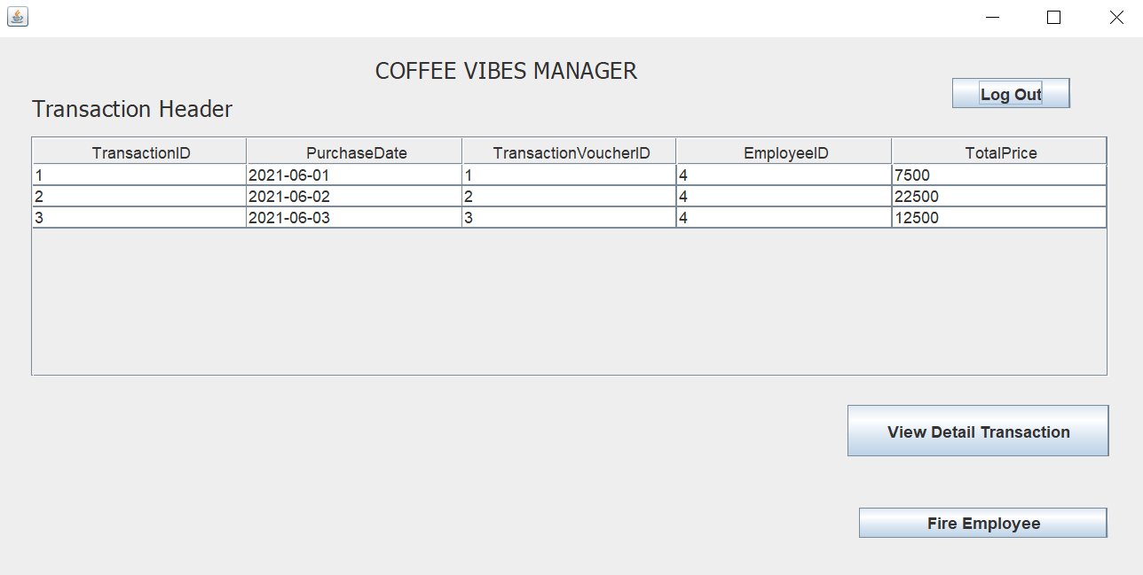

If the user (Employee) logs in as "**Manager**", the user will be taken to the main menu of the manager, "**Coffee Vibes Manager**". In this menu, the user will see a table transaction header which contains a list of transactions that have been done.

In addition, in this menu, users can also view transaction details by pressing the "View Transaction Details" button. After the user presses the button, automatically, the user will be directed to a menu as shown below.

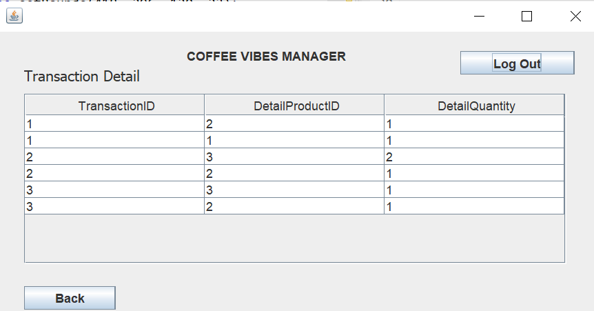

In this menu, there is a table listing the transaction details of each transaction ID. To return to the main menu of the manager (“**Coffee Vibes Manager**”), the user can press the “Back” button.

Besides being able to view transaction details, users can also fire employees (because of their position as manager). By pressing the "Fire Employee" button in the manager's main menu and after being pressed, the user will automatically be directed to the "**Coffee Vibes Employees**" menu.

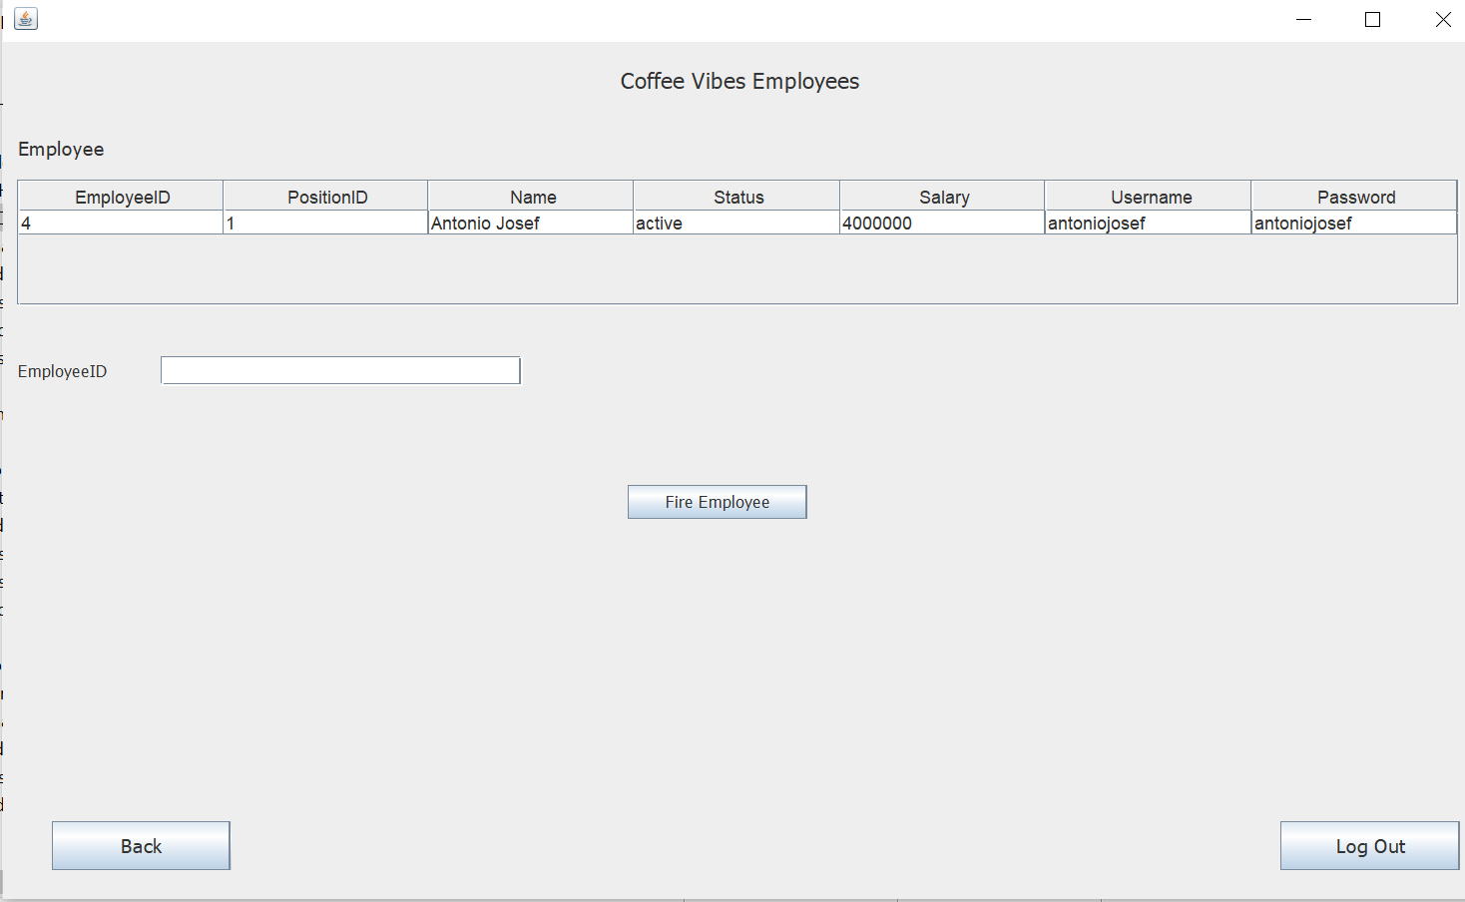

In this menu, an employee table will be displayed which consists of the employeeID and complete personal data of each employee. To perform a firing employee, the user can enter the employeeID of the employee who wants to be fired and press the "Fire Employee" button. After pressing the button, the data from the fired employee will automatically disappear from the database.

In the three menus, there is a "Log Out" button which when pressed, the user will automatically exit the "**Manager**" menu and return to the "**Log in**" menu.

1. **Menu Human Resource Department**

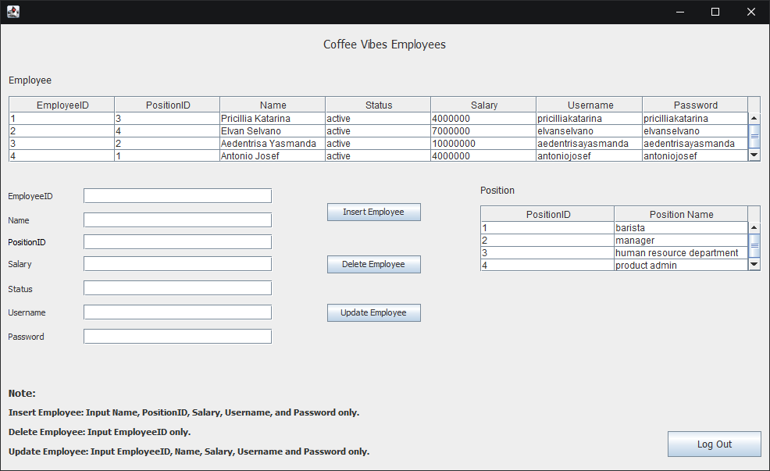

If the user (Employee) is logged in as "**Human Resource Department**", the user will be taken to the main menu of the human resource department, which will display an employee table containing personal data of employees working at Coffee Vibes cafe and a position table containing positionID and position names.

In addition, in this menu, users can also insert, update and delete employees. Where when inserting, the user only needs to enter the data name, positionID, salary, username, and password of the employee who wants to be added.

When the user wants to update the data, the user only needs to enter the employeeID, name, salary, username, and password of the employee who wants to be updated and when the user wants to delete the data, the user only needs to enter the employeeID data.In this menu, there are notes that the user can see if the user forgets what to input to insert, update and delete.

In this menu, there is also a “Log Out” button which when pressed, the user will automatically exit the “**Coffee Vibes Employee**” menu and return to the “**Log in**” menu.

* Reference
* Video Learning Class BB08
* Binus maya 🡪 Object Oriented Analysis & Design 🡪 Video learning 🡪 Session 8, session 10 dan session 11.
* Drive laboratory assistant 🡪 Session 9.

<https://binusianorg-my.sharepoint.com/personal/stephanus_harjono_binus_edu/_layouts/15/guestaccess.aspx?folderid=095838280bfc74b13b8bc74e28ef26736&authkey=AYeCWFhLyQ7lyNZtMlKk6OY&e=vUjewH>

* Group Member
* **Group ID: f1788461-2b9c-eb11-90f0-d8d385fce79e**
* 2301952943 – Aedentrisa Yasmanda Paulindino
* 2301866826 – Antonio Josef
* 2301877994 – Elvan Selvano
* 2301876291 – Pricilla Katarina